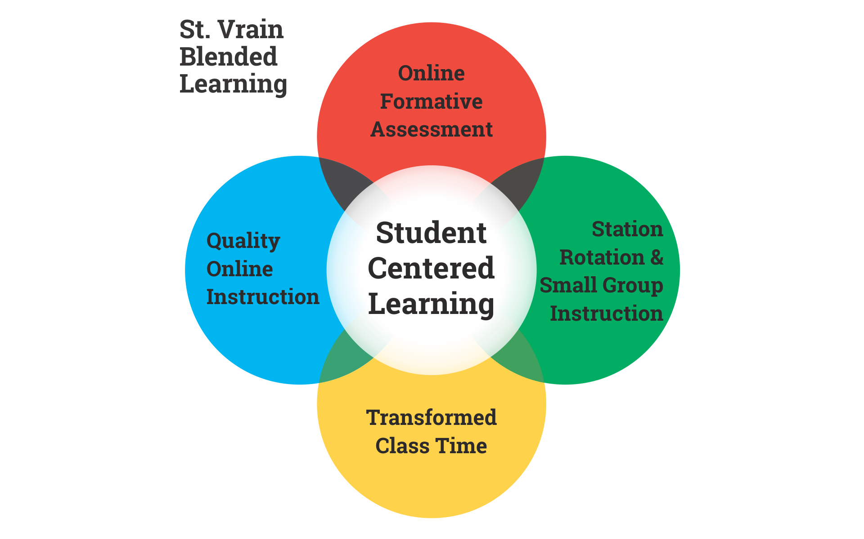

**SVVSD Definition:**

The SVVSD Blended model is a combination between research-supported practices and quality online content. **This puts the students at the center by giving them more control of the content, path, place, pace, and time of learning.** Blended Learning supports a constructivist approach by creating learning opportunities for student creation and collaboration. Key components include online formative assessment, high-quality instructional content (built in Schoology), differentiated small group instruction/station rotation, and researched-supported best practice instructional strategies.

***We have made a plan to consider all the aspects of managing the necessary changes required in order to achieve our vision of growing SVVS Blended Learning.***

Current stats:

~117 teachers throughout the district have been trained in Blended Learning over the past 4 years

~ 76 teachers are signed up for the Blended Learning in-person collaborative and 29 teachers for the Blended Badges online program for 2018-19

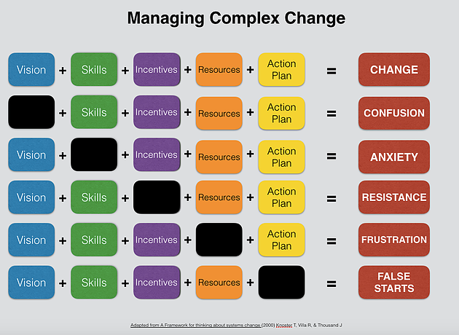

**Vision:**

SVVS students are empowered by using learning technologies to support their agency as learners, to engage in authentic work and critical thinking to be future ready students through a Blended Learning model shared across our district.

**Skills:**

* **4 Cs -** Communication, Collaboration, Creativity, Critical-Thinking
* **Quality Online Instructional Content**- Students are engaged in active learning experiences and it gives them more control of path, place, pace and time of learning.
* **Online Formative Assessments-** Teachers offer a variety of feedback loops for personalization of student learning
* **Station Rotation** - Designing stations based on formative assessment data to create opportunities for students to engage with the material in modalities to support their needs.
* **Transformed Class Time** - Instructional opportunities where students are engaging in authentic work, creating meaningful problems and questions, participating in inquiry, and using self-reflection to determine where they are on the pathway towards mastery.

**Incentives:**

* Increased student engagement and greater satisfaction in their job.
* Growth in student achievement.
* Leadership opportunities in their building.
* Facilitate online courses.
* Blended Learning credential through the iLC.

**Resources:**

|  |  |
| --- | --- |
| **People and places** | **Financial** |
| * Blended Building Leaders * Blended Learning Facilitation Team * Completed Blended Unit Plans * [Blended Component Rubrics](https://drive.google.com/open?id=1pnQ4LsbySJeoxrj04ccxkMl4U1F1rkCZ) * [Blended Conversation Cards for Admin, Coaches and teachers](https://docs.google.com/presentation/d/1uh_50s3kQB1FJ_4MC7f6mkDruRy_0GU7d2mrVphUqx0/edit?ts=5a8c942d#slide=id.g336c3670be_0_0) * 2 building locations for monthly meetings (East and West) * Schoology resources folder for teachers | * ~$10,000 for guest speakers * ~$20,000 for Blended Building Leader Stipends * ~$8,000 Blended Learning Facilitation Team Stipends * ~$5,000 for teacher credits |

**Action Plan:**

**Goal 1:** [Developing Blended Building Leaders](https://docs.google.com/document/d/10JVAOCgSzc3cO505qQkggsyP_5Epml6N7537tZbYI_A/edit)

**2018-2019:**

* Piloting the Blended Building Leaders in schools where we have people trained
* **By end of 2020-2021:** Network of Blended experts in every building to support mentoring and facilitating Blended at schools.

**Goal 2: Create PLN for SVVS Blended**

**2018-2019:**

* Developing a bank of vetted resources
* Develop Blended Lessons as resources for Unit plans
* Videotaping and finalizing the components of blended (surveys, card, video, doc)

**By end of 2020-2021:**

* Getting current and former participants involvement in PLN and utilizing the vetted resources in their

classrooms

**Goal 3: Communication Plan**

**2018-2019:**

* Communicate the SVVS vision and definition of Blended Learning to Learning Leaders, Principals and other

Stakeholders through guest blogs, informational meetings and collaboration, Vrain Waves?

**By end of 2020-2021:**

* School level goals for implementing and growing blended learning.
* Gathering feedback from stakeholders about the experiences with blended learning

**Goal 4: Multiple Pathways for Learning and Growth**

**2018-2019:**

* East and West Collaborative Cohorts
* Blended Learning Badge Cohort

**By end of 2020-2021**

* Blended PD Modules for BBL or LTC to facilitate a site-based PST